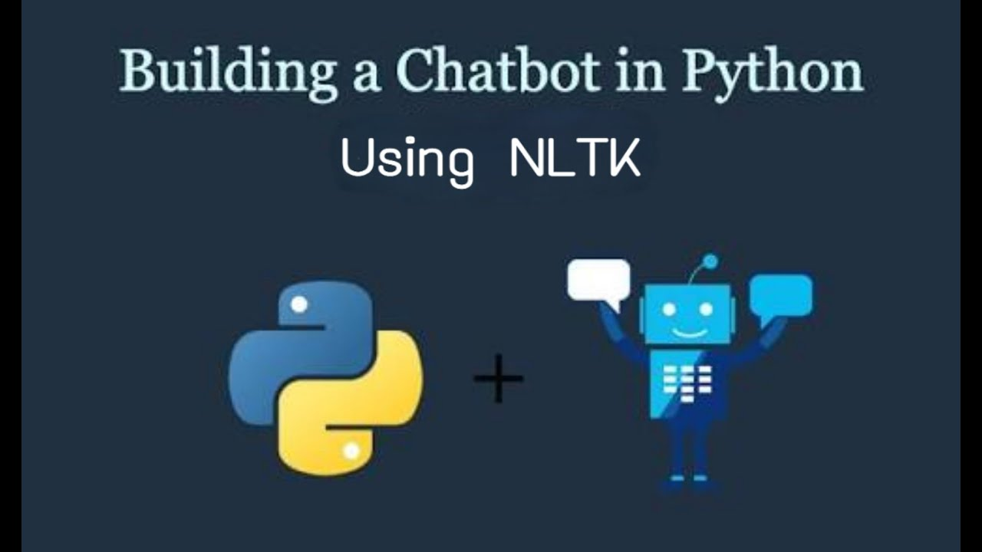

Contents:
Introduction
Existing System
Proposed System
Software Requirements
Hardware Requirements
Architectural diagram
Data flow diagram
Table Design
Data Dictionary
Relational diagram
Program design
Testing
Conclusion
References
Source code
Screen shot

Introduction:
- This project will create a chatbot using the Natural Language Toolkit (NLTK) library in Python.
- The chatbot will be able to understand and respond to natural language queries.
- The chatbot will be able to access and process information from the real world through APIs.
Existing System:
- There are many existing chatbots that are available today.
- Some of these chatbots are rule-based, while others are machine learning-based.
- Rule-based chatbots are typically simpler to create, but they are not as intelligent as machine learning-based chatbots.
- Machine learning-based chatbots are more complex to create, but they can learn and improve over time.
Proposed System:
- The proposed chatbot will be rule-based.
- This means that the chatbot will be able to understand and respond to natural language queries based on a set of rules.
- The rules will be defined in a Python file.
- The chatbot will also be able to access and process information from the real world through APIs.
Software Requirements:

=>8GB Ram
=>256 internal memory
=>intel processor

Hardware Requirements:

=>window os
=>Python Gui or Anaconda navigator(Anaconda jupyter)

Architectural Diagram:
- The architectural diagram for the proposed chatbot is shown below.

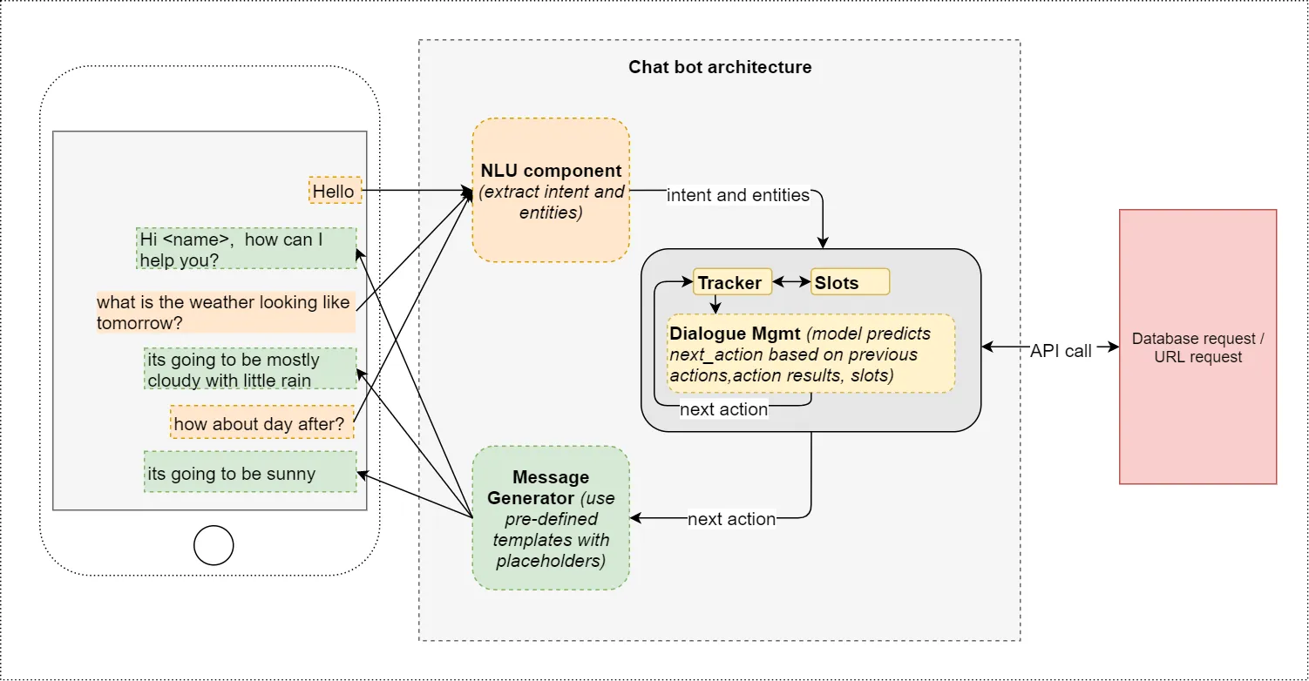
- The chatbot will be implemented as a Python program.
- The program will use the NLTK library to understand and respond to natural language queries.
- The program will also use APIs to access and process information from the real world.
Data flow Diagram:
- The data flow diagram for the proposed chatbot is shown below.
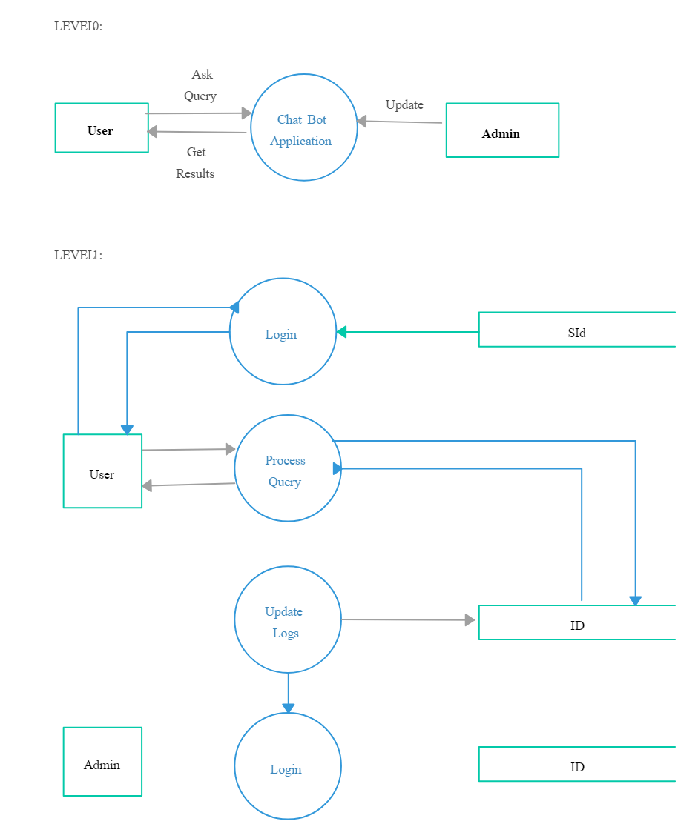
  - The chatbot will receive natural language queries from the user.
  - The chatbot will then use the NLTK library to understand the queries.
  - The chatbot will then use APIs to access and process information from the real world.
  - The chatbot will then generate a response to the user.
Table Design:
- The chatbot will use a database to store information.
- The database will contain the following tables:
  - Users: This table will store information about the users of the chatbot.
  - Queries: This table will store the queries that have been submitted to the chatbot.
  - Responses: This table will store the responses that have been generated by the chatbot.
Data Dictionary:
- The data dictionary for the proposed chatbot is shown below.
- | Table | Column | Data Type | Description | |---|---|---|---| | Users | ID | Integer | The unique identifier for the user. | | Username | Username | String | The username of the user. | | Email | Email | String | The email address of the user. | | Password | Password | String | The password of the user. | | Queries | ID | Integer | The unique identifier for the query. | | UserID | Integer | The ID of the user who submitted the query. | Query | String | The query that was submitted by the user. | | Response | String | The response that was generated by the chatbot. |
Relational Diagram:
- The relational diagram for the proposed chatbot is shown below.
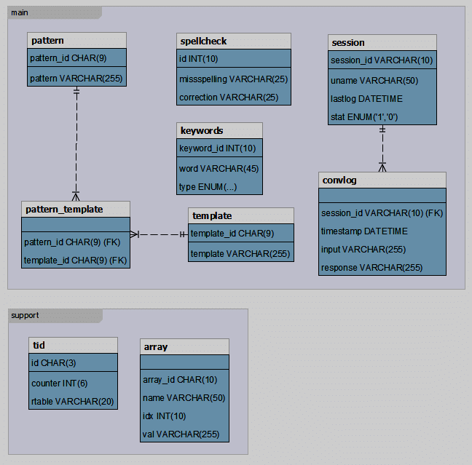
Program Design:
- The program design for the proposed chatbot is shown below.
- The program will be implemented as a Python file.
- The program will use the NLTK library to understand and respond to natural language queries.
- The program will also use APIs to access and process information from the real world.
Testing:
- The chatbot will be tested using a variety of methods, including:
  - Unit testing
  - Integration testing
  - System testing
  - User acceptance testing
Conclusion:
- The proposed chatbot will be a valuable tool for users who need to access information from the real world through natural language queries.
- The chatbot will be easy to use and will be able to provide accurate and relevant information.
Reference:
=>In these project we can create the chatbot by using NLTK
=>From these project we can interact with the computer and computer gave response like the human for questions
=>After building the model we can deploy it into server

